# Computer Programming Lab 9

**Nabeel Ali BEE173059 Section-3**

## Activity 1:

#include <stdio.h>

#include <stdlib.h>

MaxMin(int X[10], int *max, int *min);

main()

{

int X[10], *ptr = X, max, min, i;

for (i = 0; i < 10; i++)

{

*ptr = rand();

ptr++;

}

ptr = X;

for (i = 0; i < 10; i++)

{

printf("%d\n", *ptr++);

}

MaxMin(X, &max, &min);

printf("Max = %d\n", max);

printf("Min = %d\n", min);

}

MaxMin(int X[10], int *max, int *min)

{

int *ptr = X, i;

*max = X[0];

*min = X[0];

for (i = 0; i < 10; i++)

{

*max = *ptr > *max ? *ptr : *max;

*min = *ptr < *min ? *ptr : *min;

ptr++;

}

}

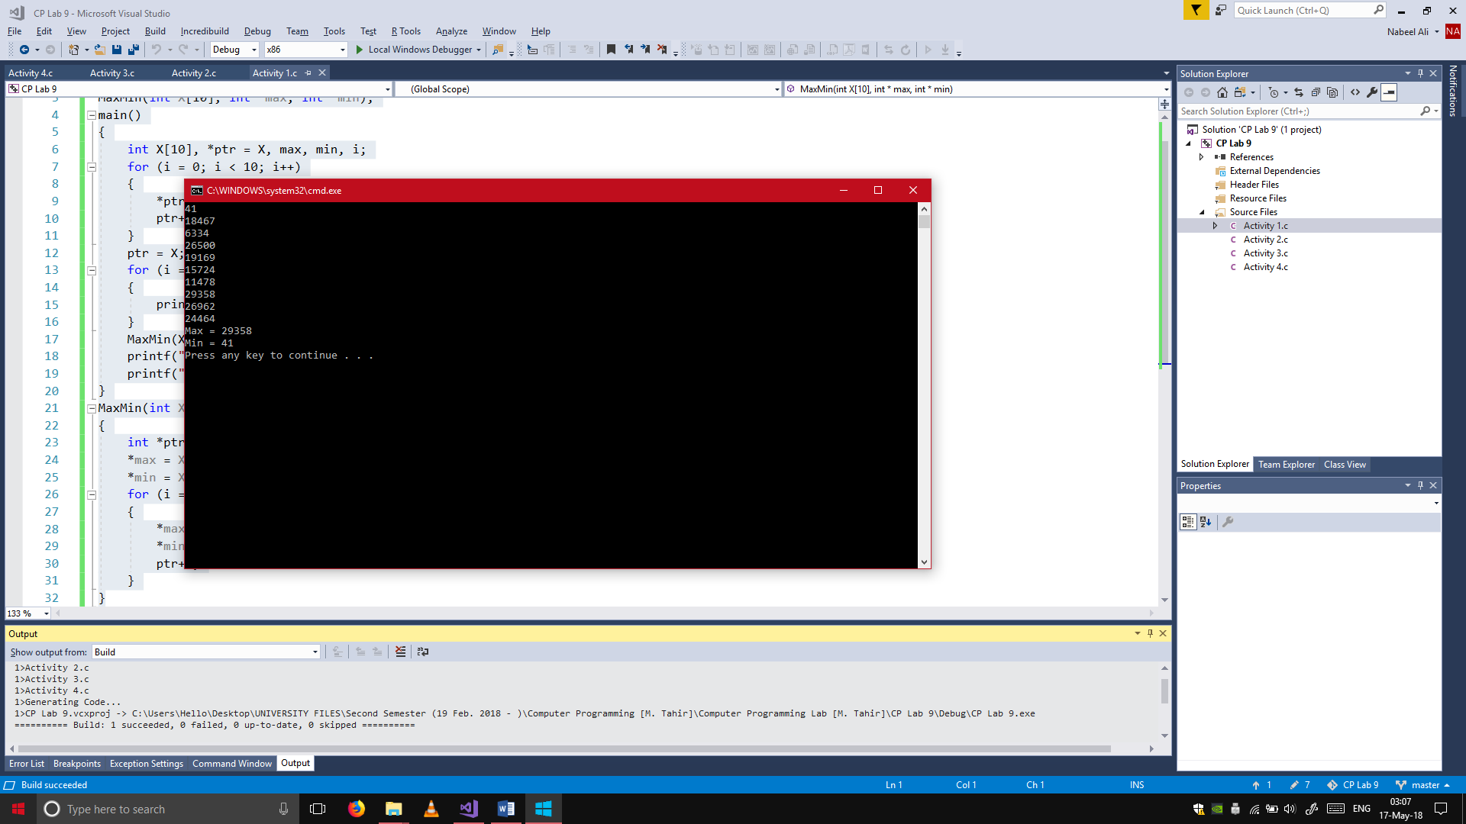

## Activity 2:

#include <stdio.h>

main()

{

int X[3][3], Y[3][3], Z[3][3], i, j, counter;

int *ptrX, *ptrY, *ptrZ;

counter = 1;

for (i = 0; i < 3; i++)

{

for (j = 0; j < 3; j++)

{

printf("Enter the %d value of the 1st matrix: ", counter++);

scanf("%d", &X[i][j]);

}

}

counter = 1;

for (i = 0; i < 3; i++)

{

for (j = 0; j < 3; j++)

{

printf("Enter the %d value of the 2nd matrix: ", counter++);

scanf("%d", &Y[i][j]);

}

}

ptrX = X;

ptrY = Y;

ptrZ = Z;

for (i = 0; i < 9; i++)

{

*ptrZ = *ptrX + *ptrY;

ptrX++;

ptrY++;

ptrZ++;

}

ptrZ = Z;

for (i = 0; i < 9; i++)

{

printf("\t%d", *ptrZ++);

if (i == 2 || i == 5)

{

printf("\n");

}

}

printf("\n");

}

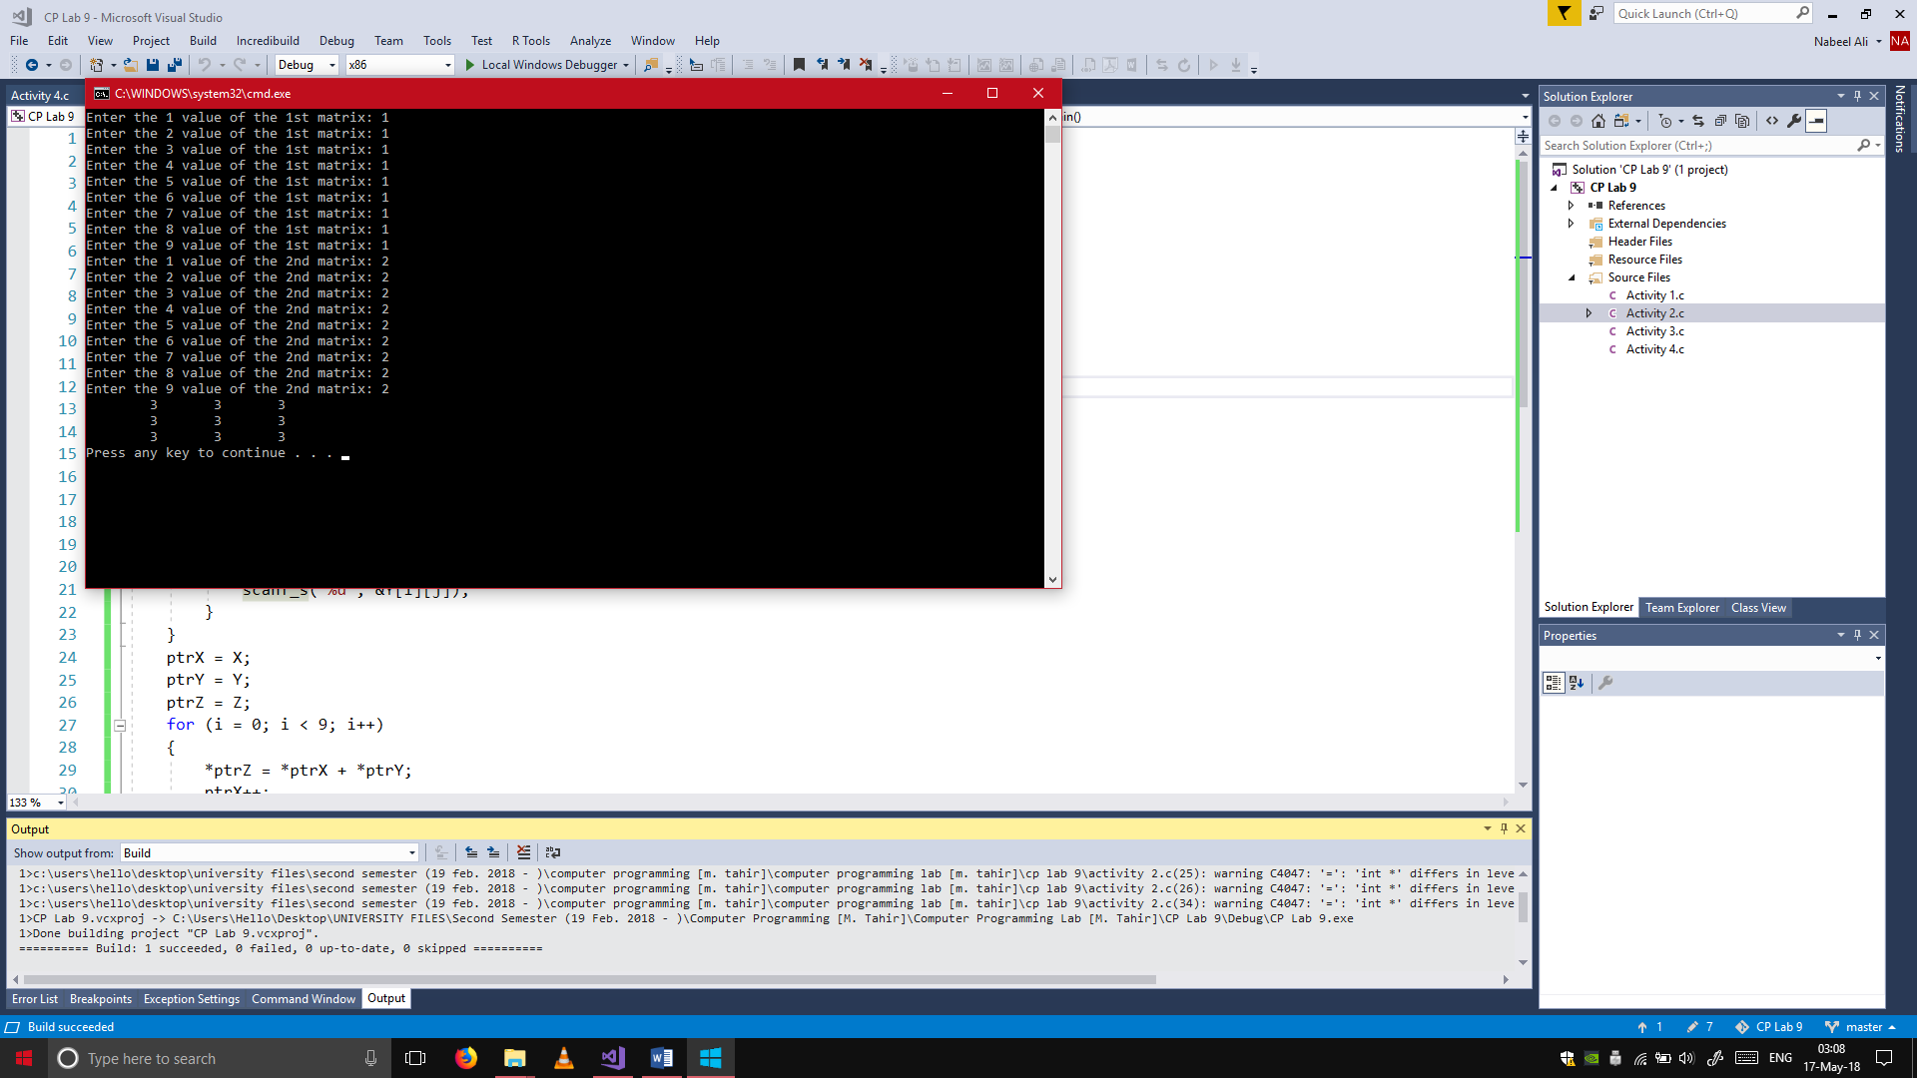

## Activity 3:

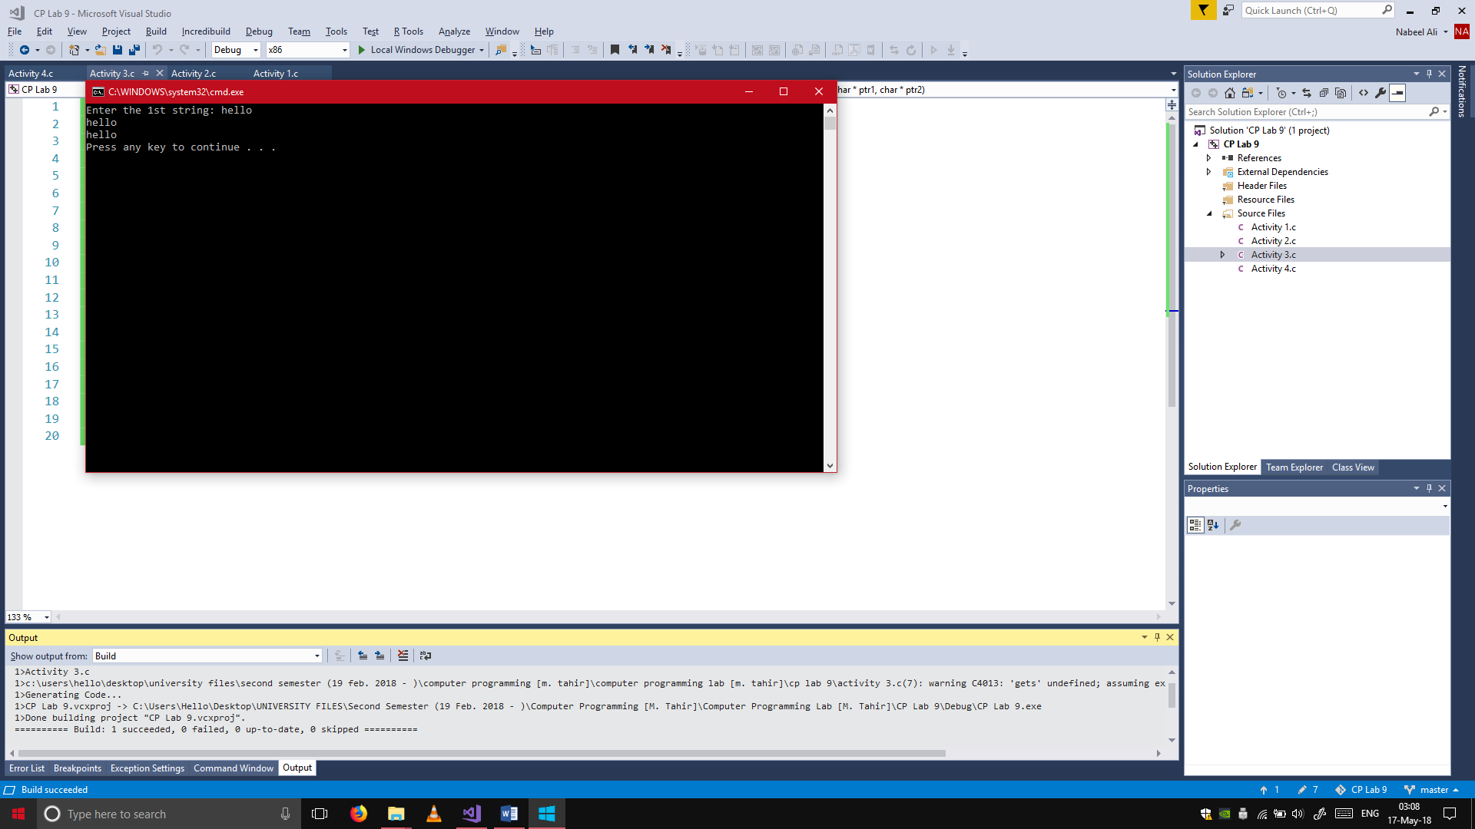#include <stdio.h>

strcpy(char *ptr1, char *ptr2);

main()

{

char X[10], Y[10];

printf("Enter the 1st string: ");

gets(X);

strcpy(X, Y);

printf("%s\n", X);

printf("%s\n", Y);

}

strcpy(char *ptr1, char *ptr2)

{

for (int i = 0; i < 10; i++)

{

*ptr2 = *ptr1;

ptr1++;

ptr2++;

}

}

## Activity 4:

#include <stdio.h>

main()

{

char names[10][20];

int *ptr[10], i, j, counter = 0;

for (i = 0; i < 10; i++)

{

printf("Enter the %d name: ", i+1);

scanf("%s", &names[i]);

}

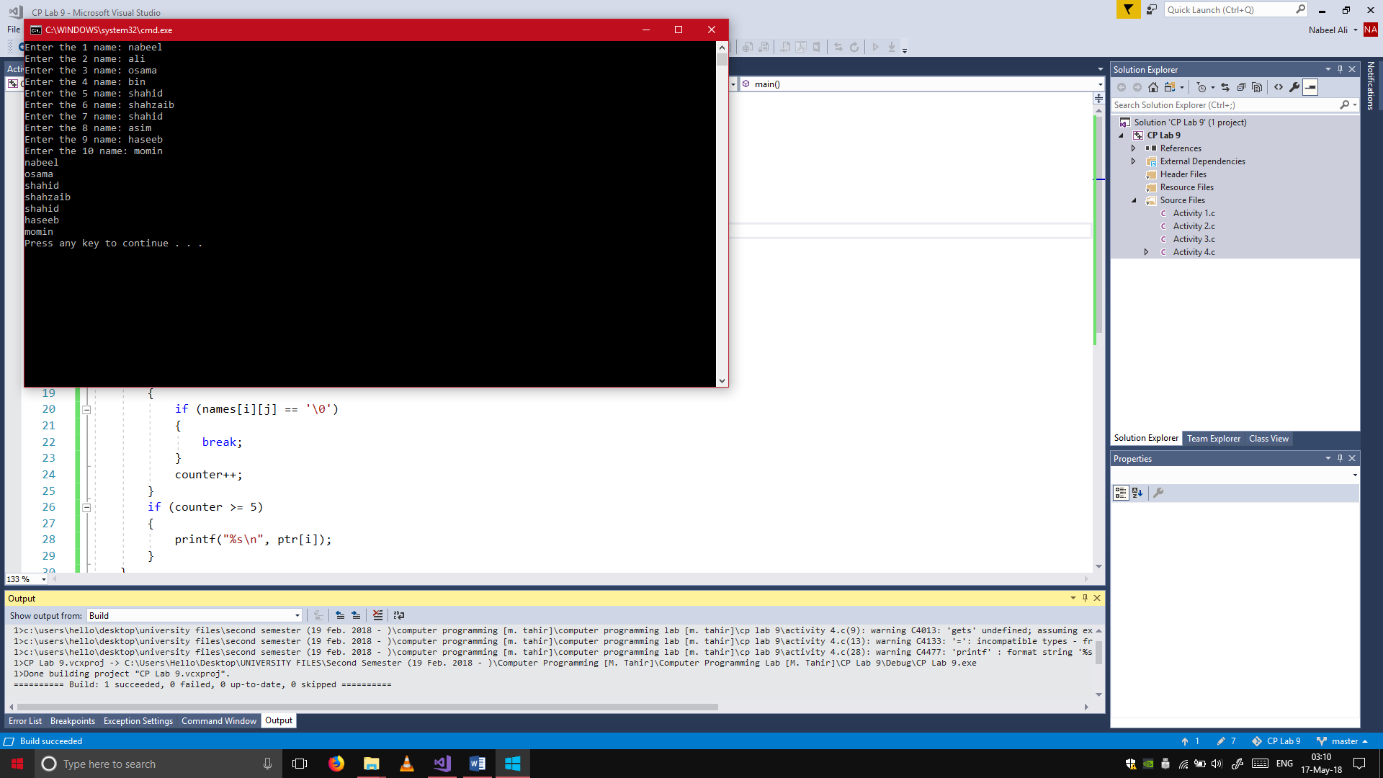 for (i = 0; i < 10; i++)

{

ptr[i] = names[i];

}

for (i = 0; i < 10; i++)

{

counter = 0;

for (j = 0; j < 20; j++)

{

if (names[i][j] == '\0')

{

break;

}

counter++;

}

if (counter >= 5)

{

printf("%s\n", ptr[i]);

}

}

}

## Bonus Activity 2:

#include <stdio.h>

main()

{

int X[10], Y[10], Z[20], i;

int *ptr1 = X, *ptr2 = Y, *ptr10 = Z;

for (i = 0;i < 10;i++)

{

printf("Enter the %d number for the 1st array: ", i+1);

scanf_s("%d", &X[i]);

}

for (i = 0;i < 10;i++)

{

printf("Enter the %d number for the 2nd array: ", i + 1);

scanf_s("%d", &Y[i]);

}

for (i = 0;i < 20;i++)

{

if (i % 2 == 0)

{

*ptr10 = *ptr1;

ptr1++;

}

else

{

*ptr10 = *ptr2;

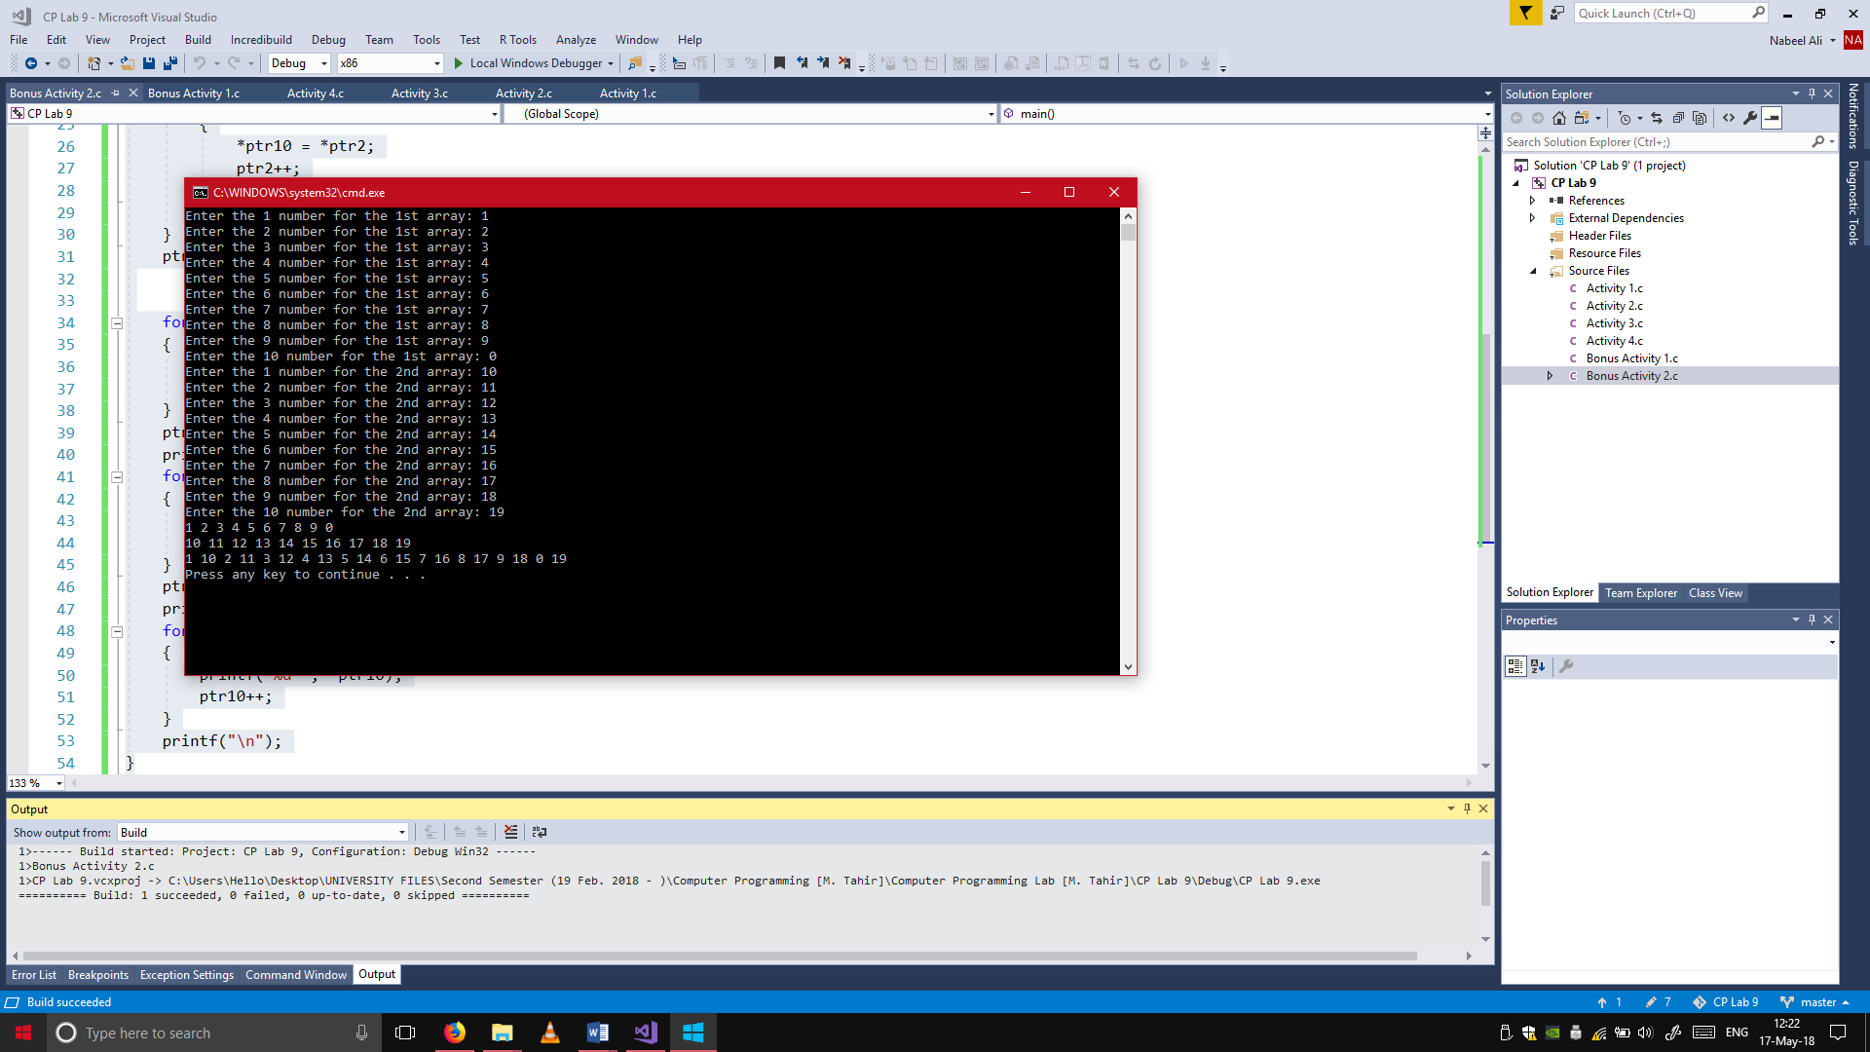 ptr2++;

}

ptr10++;

}

ptr1 = X;

for (i = 0;i < 10;i++)

{

printf("%d ", *ptr1);

ptr1++;

}

ptr2 = Y;

printf("\n");

for (i = 0;i < 10;i++)

{

printf("%d ", *ptr2);

ptr2++;

}

ptr10 = Z;

printf("\n");

for (i = 0;i < 20;i++)

{

printf("%d ", *ptr10);

ptr10++;

}

printf("\n");

}